**Overview**

The Consumer Financial Protection Bureau (“CFPB” or the “Bureau”) has implemented Zscaler, a Zero Trust Architecture (ZTA). The purpose of this guide is to provide an overview and instruction for the Technology and Innovation (T&I) Infrastructure Service Desk and Deskside Support Technicians to troubleshoot and resolve incidents.

Installation Packages

* **Windows (System Center Configuration Manager (SCCM))**
  + UDA - Zscaler (AOVPN Cutover)
  + UDA – Zotero v6.0.6 Install Collection
* **macOS (JamF)**
  + Migrate from AOVPN to Zscaler (Self Service)
* **iOS - when? (ask Mike Erps about pilot group and timeline)**
  + ???

Zscaler Service Components

* **Zscaler Client Connector (ZCC)** - Provides seamless user experience by automatically recognizing when you connect to a CFPB-trusted network or to Wi-Fi hotspots (e.g., airports, hotels) where you must accept a use policy before connecting.
* **Zscaler Private Access (ZPA)** - Establishes secure connections to allow users to securely access enterprise applications and services from outside the CFPB network from any location.
* **Zscaler Internet Access (ZIA)** – Protects end-user internet traffic to external sites even on non-CFPB networks, including mobile traffic on Wi-Fi or cellular networks.
* **Zscaler Digital Experience (ZDX)** – Monitors CFPB device for connectivity to detect end-user experience or connectivity issues. ZDX relies on ZCC to perform probing to desired Software-as-a-Service (SaaS) applications or internet-based services (e.g., OneDrive, Teams, etc.).

ZCC is installed on all Windows, macOS, and iOS mobile devices to ensure access to internal and external resources follow Bureau policies, on CFPB and non-CFPB networks.

Open ZCC by right clicking the icon in the taskbar and selecting **Open Zscaler/Open**.

Windows macOS

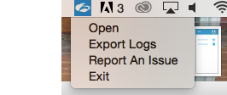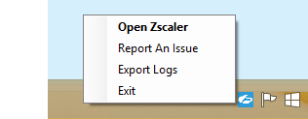

Resolving Private Access (ZPA) Connectivity Issues

**Keywords:** Zscaler,ZPA, access, connectivity, authentication, client, intranet

**Symptoms:** Authentication issues or access to CFPB internal apps, services, and other resources.

**Error Message(s)**

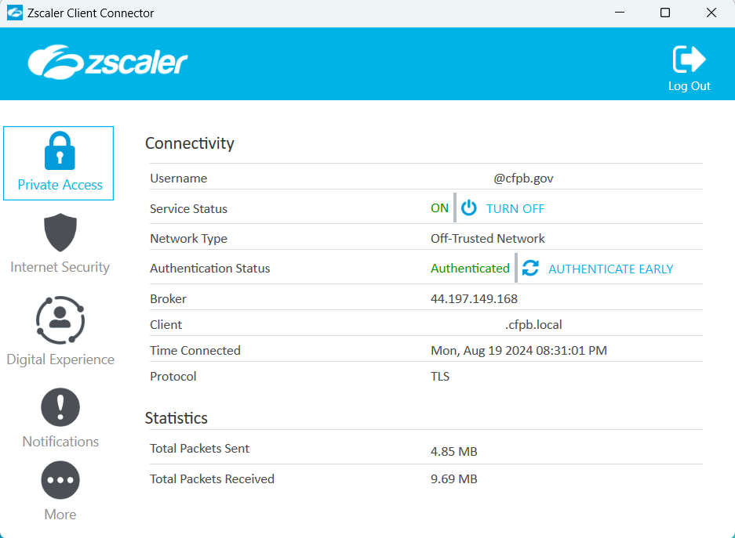

**Troubleshooting:** Navigate to Private Access > Connectivity to check the following:

* **Username:** Displays the correct CFPB email address for the user.
* **Service Status:** Status should be set to ON.
* **Network Type:** Displays the type of network you are connected to (Trusted Network, VPN Trusted Network, Split VPN Trusted Network, or Off-Trusted Network).
* **Authentication Status:** Authenticated

**Note:** Click Authenticate Early to reauthenticate ZPA before authentication expires.

* **Broker:** Displays the IP address of the server to which your traffic is being forwarded.
* **Client:** Displays the local IP address of user’s device, ending in .fcpb.local
* **Time Connected:** Displays initial connection time for the present session.
* **Protocol:** Displays the protocol used for the tunnel (TLS or DTLS).

**Resolution:** *Click* Turn Off  to toggle the service off and on in the Service Status setting.

**Note:** This turns off the Zscaler Tunnel (Z-Tunnel) and disables the ZPA service while remaining logged into the app. The Private Access service is disabled until you *click* Turn On.

Resolving Internet Security (ZIA) Connectivity Issues

**Keywords:** Zscaler,ZIA, access, connectivity, authentication, client, internet, slowness

**Symptoms:** Issues with access or slowness to external websites (includes Cloud Office). Disconnect and get screenshots of error message.

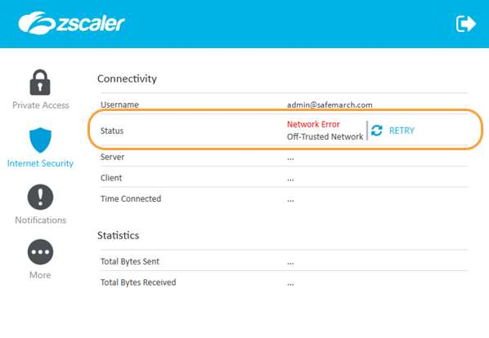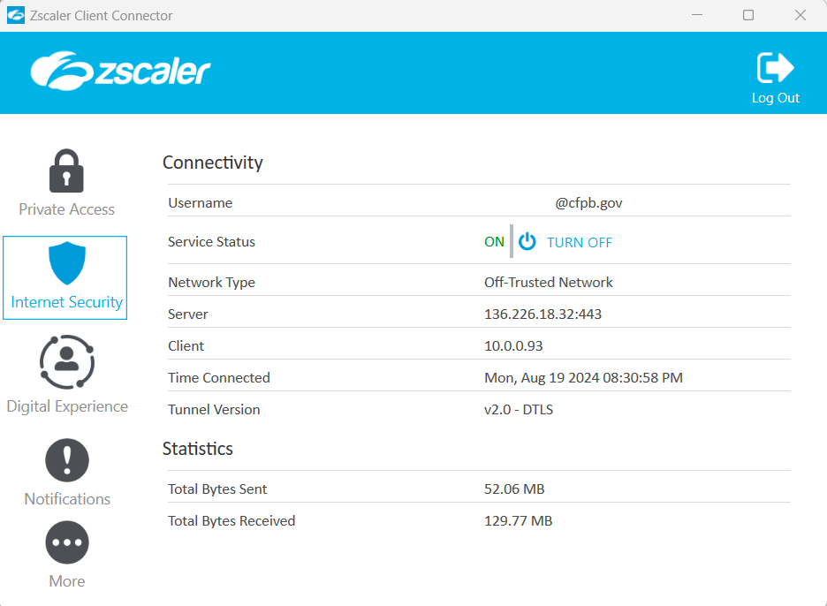

**Troubleshooting:** Navigate to Internet Security > Connectivity to check the following:

* **Username:** Displays the CFPB email address for the user.
* **Service Status:** Status should be set to ON.
* **Network Type:** Displays the type of network you are connected to (Trusted Network, VPN Trusted Network, Split VPN Trusted Network, or Off-Trusted Network).
* **Server:** Displays the IP address of the server to which your traffic is being forwarded.
* **Client (IP):** Displays the local IP address of user’s device, ending in .fcpb.local
* **Time Connected:** Displays initial connection time for the present session.
* **Tunnel Version:** Displays the protocol used for the tunnel (TLS or DTLS).

**Resolution:** *Click* Turn Off  to toggle the service off and on in the Service Status setting.

**Note:** This disables the ZIA service while remaining logged into the app. The ZIA service is disabled until you click Turn On.

Depending on your organization's policies, you might be required to enter a password.

Resolving Digital Experience (ZDX) Connectivity Issues

**Keywords:** Zscaler,ZDX, access, connectivity, authentication, client, internet, slowness

**Symptoms:** Issues with access or slowness to external websites and/or internal resources.

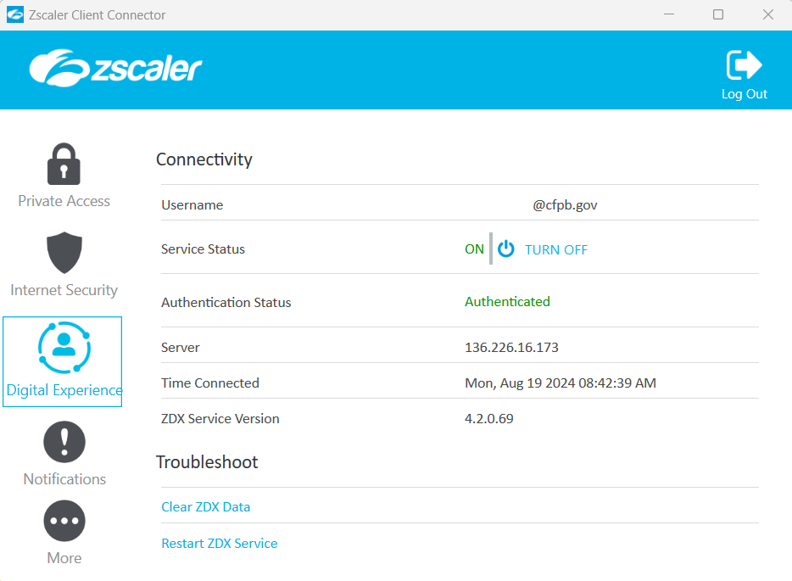

**Troubleshooting:** Navigate to Digital Experience > Connectivity to check the following:

* **Username:** Displays the CFPB email address for the user.
* **Service Status:** Status should be set to ON.
* **Authentication Status:** Authenticated
* **Server:** Displays the IP address of the server to which your traffic is being forwarded.
* **Time Connected:** Displays initial connection time for the present session.
* **Tunnel Version:** Displays the protocol used for the tunnel (TLS or DTLS).

**Resolution 1:** *Click* Turn Off  to toggle the service off and on in the Service Status setting.

**Note:** Disables the Zscaler Tunnel (Z-Tunnel) and the Digital Experience (ZDX) service while remaining logged into the app. The Digital Experience service is disabled until you click Turn On.

**Resolution 2:** *Click* Restart ZDX Service under Troubleshoot to restart the ZDX service.

Escalate if it is not resolved.

Resolving Zscaler Client Connector (ZCC) App Issues

**Keywords:** Zscaler,ZCC, access, connectivity, authentication, client, internet, slowness

**Symptoms:** Issues with access or slowness to external websites and/or internal resources.

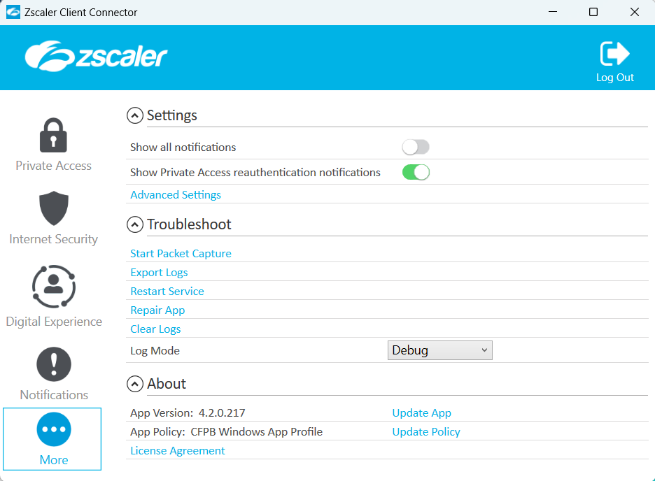

**Troubleshooting:** In the **More…** menu, under **Troubleshoot**, use the following:

* **Restart Service:** Click to restart the app. Restarting does not impact security enforcement.
* **Repair App:** This will attempt to repair by reinstalling app drivers and services.

**Note:** Zscaler recommends trying this option before reporting an issue.

**Meet with David about next step in command prompt.**

**Resolution 1:** *Click* Restart Service.

**Note:** Restarting the app doesn't affect security enforcement. If the error persists, try Resolution 2.

**Resolution 2:** *Click* Repair App.

**Note:** Attempts to repair the app by reinstalling app drivers and services. This option is only available for Windows.

## Resolution using Zscaler Client Connector (ZCC) Tools

**Keywords**:Zscaler,ZCC, access, connectivity, authentication, client, internet, slowness

**Symptoms**:Issues with access or slowness to external websites and/or internal resources.

### **Level 1: Probing Questions**

* Have you rebooted your device recently? If yes, but this has not resolved the issue, proceed

**Troubleshooting**:In the **More…** menu, under **Troubleshoot**, use the following:

#### **Restart Service**:

*Click* Restart Service.

**Note:** Restarting the app doesn't affect security enforcement. If the error persists, try Resolution 2.

#### **Repair App**:

**Note:** Zscaler recommends trying this option before reporting an issue.

*Click* Repair App.

**Note:** Attempts to repair the app by reinstalling app drivers and services. This option is only available for Windows.

#### **Repair with command prompt.**

Troubleshooting Zscaler in iOS (TBD)

Access the Troubleshoot menu the Zscaler Client Connector App by clicking on **More.**

* **Start Packet Capture:** Captures packet, you can use this feature when reproducing an issue. To learn more, see [Using the Start Packet Capture Option](https://help.zscaler.com/client-connector/enabling-packet-capture-zscaler-client-connector).
* **Export Logs:**
* **Restart Service:** You can click to restart the app. Restarting does not impact security enforcement.
* **Repair App:** If you select this option, the app will attempt to repair itself by reinstalling app drivers and services. Zscaler recommends trying this option before reporting an issue.
* **Clear Logs**: You can clear stored logs.
* **Log Mode:** You can change the mode in which Zscaler Client Connector generates logs, but the change is effective for that connection session only. At the start of the next connection session, the app returns to the default log mode set by your organization. Below is a description of each log mode.
  + - **Error:** Logs only when the app encounters an error and functionality is affected.
    - **Warn:** Logs when the app is functioning but is encountering potential issues, or logs when conditions for the Error log mode are met.
    - **Info:** Logs general app activity, or logs when conditions for the Warn log mode are met.
    - **Debug**: Logs all app activity that could assist Zscaler Support in debugging issues, or logs when conditions for the Info log mode are met.

Notifications

Hovering a cursor above the Zscaler icon in the tray icon will show notifications as shown below.

Windows 11

macOS

To enable the system tray notifications:

1. Open ZCC by right clicking the icon in the taskbar and select **Open Zscaler**.
2. On the left-hand menu, *select* **More…** and **Settings**.

**NOTE:** This section includes slider buttons to **Show all notifications** and to **Show Private Access reauthorization notifications**. There is also a drop-down menu for **Do Not Disturb (DND) Mode**.

1. Once complete, close out of the app.

**Note:** You might be required to enter a password your organization's admin has set for the app. If you log out of the app, you must complete enrollment again when you log back in.

|  |  |  |
| --- | --- | --- |
| **Done? 🗹** |  |  |
|  | **Username** |  |
|  | **Service Status** |  |
|  | **Network Type** |  |
|  |  |  |
|  |  |  |
|  |  |  |
|  |  |  |